Name: Umamah Binti Aziz SAP ID: 72012
COAL LAB
Lab Tasks 08

Task 01:
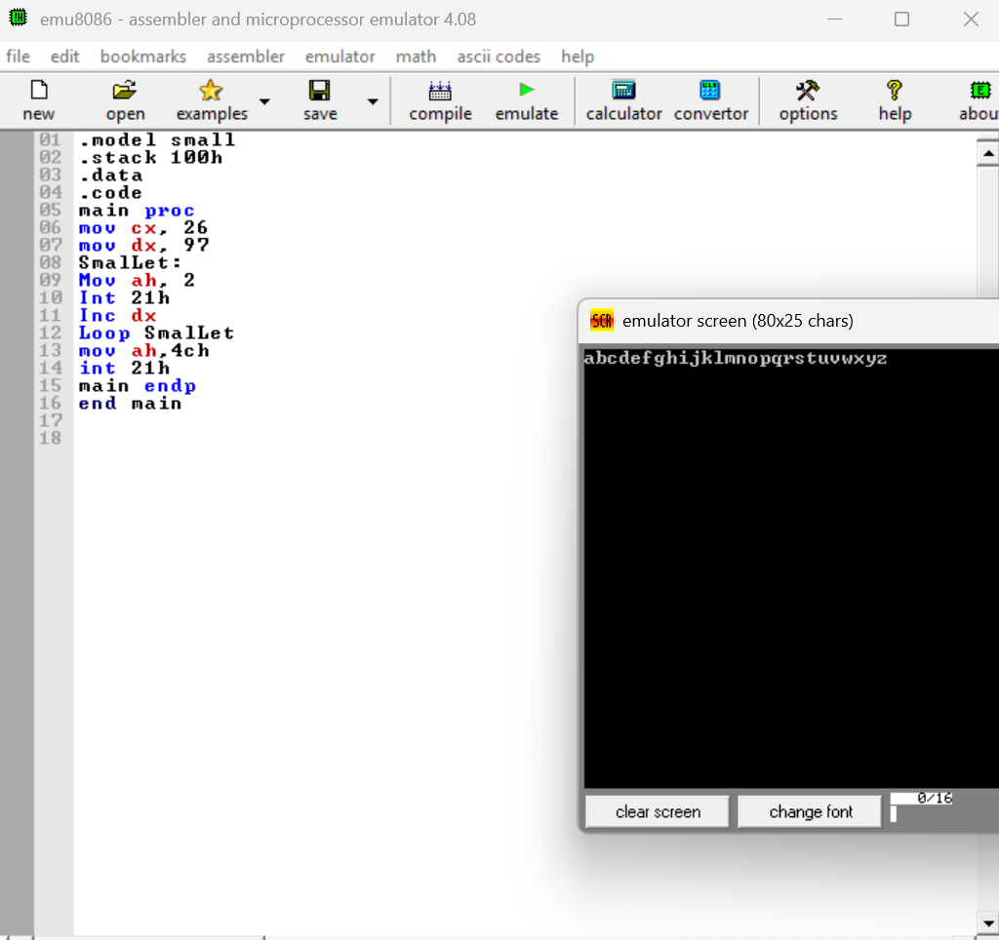

Task 02:
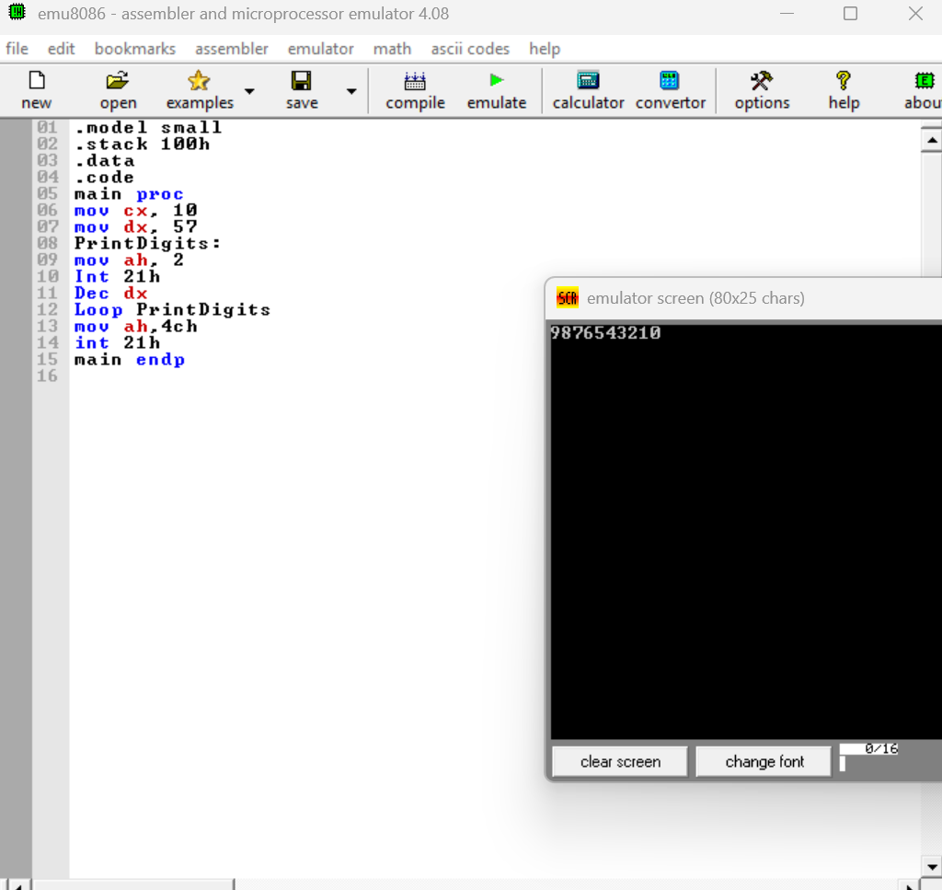

Task 03:
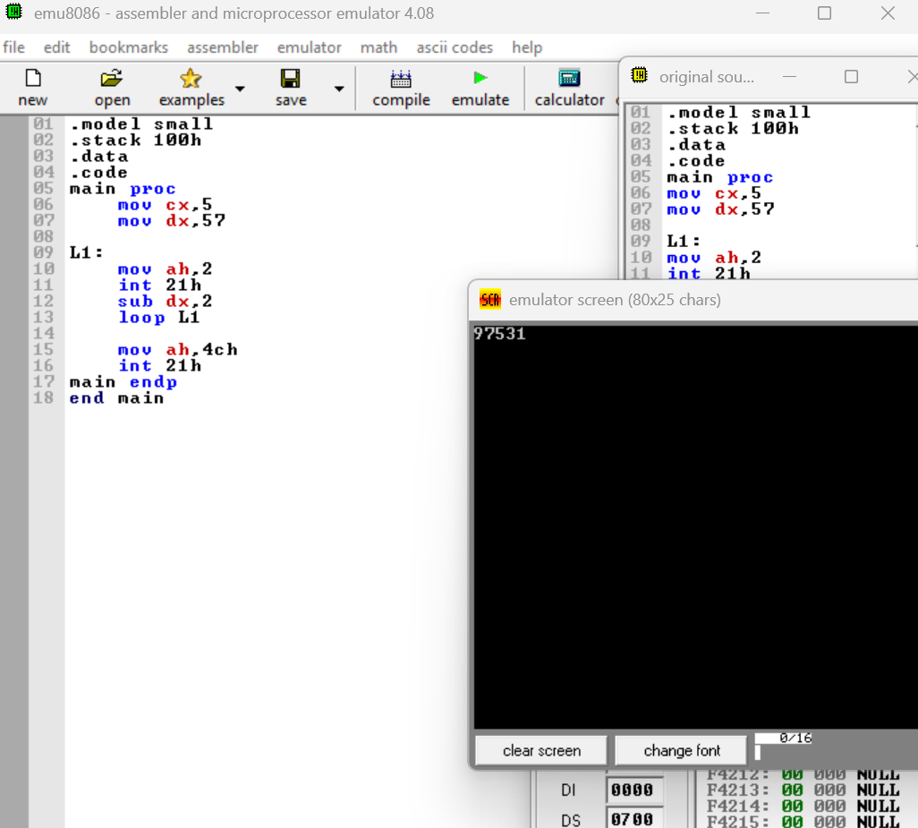

Task 04:
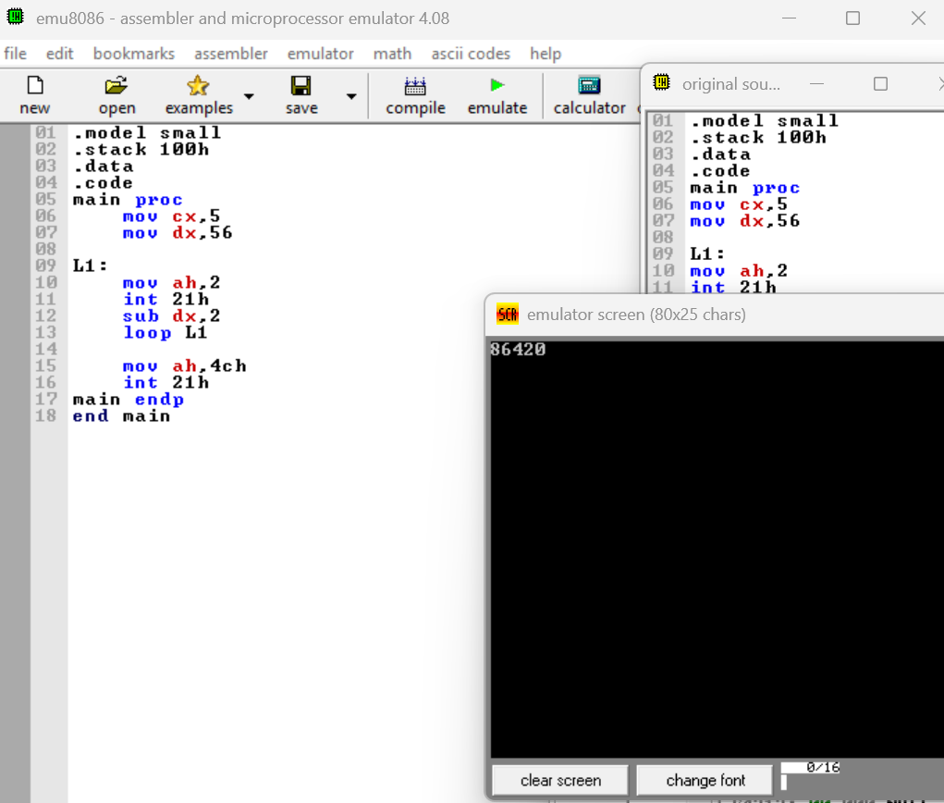

Task 05:


